Bin Monitor

Launching
- Double-Click

Monitor Screen
The monitor screen is broken up into three sections:
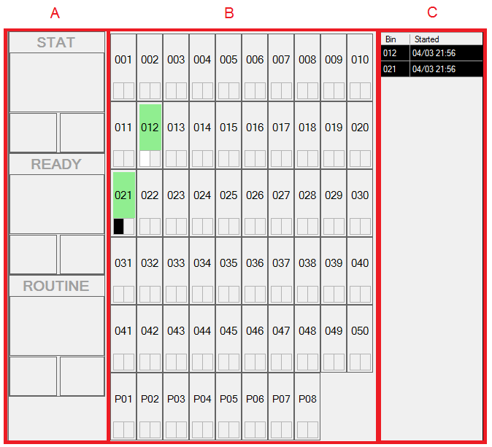
- Next Due Panel: Quickly shows the next 3 bins that should be checked out from each category.
- Bingo Board: Overview of the status of all bins.
- Grid View: Overview of all active bins sorted by category and creation time.

Batch Status Display
Each bingo board item displays the following information

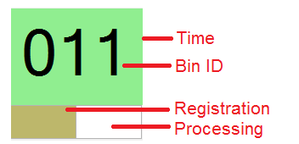
- Bin ID: The ID printed on the front of the bin containing the specimens
- Time: The background color changes to reflect how long the item has been on the shelf, as the batch ages, the color will change from green to yellow to orange to red to indicate the severity of the batch.
- Registration: Status of the registration workflow step. Grey if not started, White if started, and a color that corresponds with the batch’s assigned category if completed.
- Processing: Status of the processing workflow step. Same color conventions as the registration.

Manager Screen
To launch the manager, click [Launch Manager] from the top menu of the monitor screen. Most day-to-day operations will be controlled from the [User Functions] and [Manager Functions]. These functions operate on single-use authentication. For advanced functions, users can create a session by using the [Authenticate] button at the top and selecting the tabs.
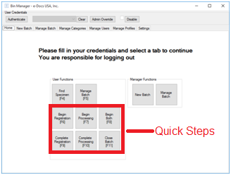

Creating a New Batch [Manager]
- Click [New Batch]
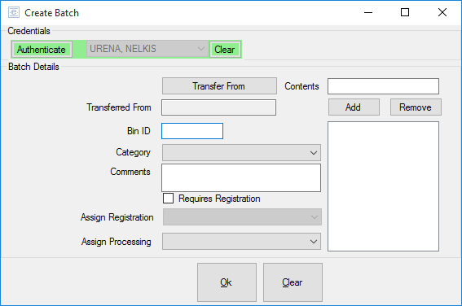
- When prompted, authenticate, by placing your ID badge on the reader.
Note: If admin override is enabled, you will just need to select your CWID from the list.
- Enter the Bin ID (keyboard or using the barcode reader).
- Select a category from the dropdown.
- If the batch requires registration, check the [Requires Registration] checkbox.
- If you want to assign registration and/or processing steps at this time, select the assigned users from the corresponding drop downs.
- Enter each of the specimens (keyboard or barcode reader).
- Click [Ok]

Transferring Contents of a Batch [Manager]
- Click [New Batch]
- Click [Transfer From]
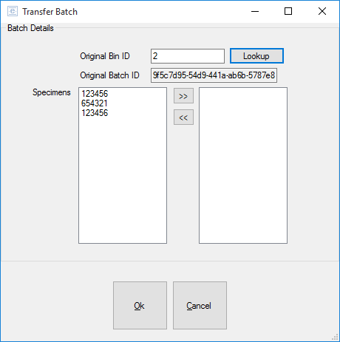
- Enter the Bin Id where the specimens are being transferred from and click [Lookup].
- Double-Click on each specimen to transfer to the new bin.
- Click [OK] and continue with the directions for creating a new bin.

Finding a Specimen [User or Manager]
Note: Only current active batches can be searched. Once a batch is closed, its specimens are no longer accessible through this function.
- Click [Find Specimen]
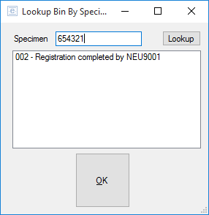
- Enter the specimen ID and click [Lookup]
- A listing of all bins containing the specimen along with the current status will be displayed.

Starting and Completing Workflow Steps [User or Manager]
Each batch has 2 workflow steps
- Registration
- Processing
Once both steps are completed, the batch can be closed which will remove it from the monitor and the empty bin can then be returned for use on another future batch.
Workflow steps can be started and completed using the individual quick functions. These functions all follow the same template.
- Click a quick step function button ([Begin Registration], etc).
- When prompted, authenticate, by placing your ID badge on the reader.
Note: If admin override is enabled, you will just need to select your CWID from the list.
- Enter the bin id (keyboard or using the barcode reader) and click [OK].
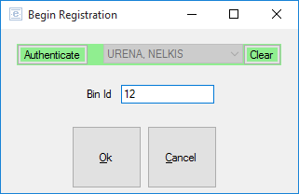

Advanced Batch Management [User]
To lookup the current status of a batch, or to add a comment to a batch:
- Click [Manage Batch] from the [User Functions]
- When prompted, authenticate, by placing your ID badge on the reader.
Note: If admin override is enabled, you will just need to select your CWID from the list.
- Enter the Bin ID (keyboard or barcode reader).
Note: If you don’t know the Bin Id, fill in the Specimen ID, click [Lookup] and select a bin from the drop-down.
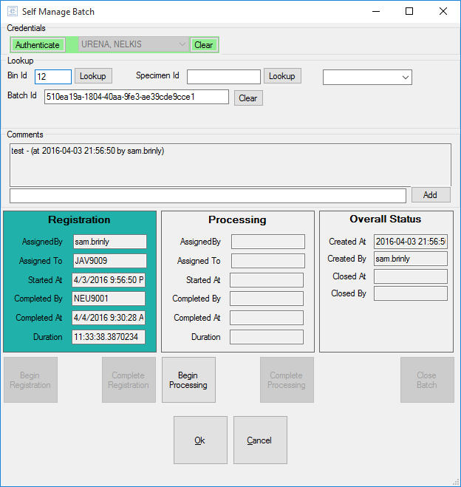
- From here, you can also start and stop workflow steps.

Advanced Batch Management [Manager]
- Click [Manage Batch] from the [Manager Functions]
The advanced management for managers is largely identical to the advanced batch management for users with the following exceptions:
- Correcting a batch’s category (Click the […] button next to category and choose the correct category).
- Starting and completing workflow steps. Managers will be able to assign workflow steps to other users rather than having all assignments done to the current user.

